Akdeniz University
Department of Computer Engineering
Software Engineering Project
Project short-name: Training Tracking

Software Requirements Specification & Analysis
Ozan Engin, Gülsüm Simge Bozdoğan, Muhammet Uçar

Team Leader: Ozan Engin
Product Owner: Gülsüm Simge Bozdoğan, Muhammet Uçar

Instructor: Assoc. Prof. Ümit Deniz ULUŞAR

23.04.2021

This report is submitted to the Department of Computer Engineering of Akdeniz University of the Software Engineering course CSE332.

Abbreviations
IP | Internet Protocol
TFF | Turkey Football Federation
XML | Extensible Markup Language

Contents
1 Introduction 1
1.1 Purpose 1
1.2 Product Scope 1
1.3 References 1
2 Overall Description 1
2.1 Product Perspective 1
2.2 Product Functions 2
2.3 User Types and Characteristics 2
2.4 Operating Environment 2
2.5 Design and Implementation Constraints 2
2.6 User Documentation 3
2.7 Assumptions and Dependencies 3
3 External Interface Requirements 3
3.1 User Interfaces 3
3.2 Hardware Interfaces 3
3.3 Software Interfaces 3
3.4 Communications Interfaces 4
4 System Features 4
4.1 User Class 1 <Administrator> 4
4.1.1 System Feature 1 4
4.1.1.1. Description and Priority 4
4.1.1.2. Stimulus/Response Sequences 4
4.1.1.3. Functional Requirements 4
5 Nonfunctional System Requirements 6
5.1 Performance Requirements 6
5.2 Safety Requirements 6
5.3 Security Requirements 6
5.4 Software Quality Attributes 7
5.5 Business Rules 7
6 Other Requirements 7
7 System Models 8
7.1 System Context 8
7.2 Interaction Models 9
7.2.1 Use-Case Models and Wireframe 9
7.2.1.1. Mental Care system: Transfer data 9
7.2.1.2. Mental Care system: Register Patient 10
7.2.2 Sequence Diagrams 11
7.2.2.1. View Patient 11
7.3 Structural Models 13
7.3.1 Object and Class Model 13
7.3.1.1. Consultation Class (For important classes only) 14
7.3.1.2. Doctor Class 15
7.3.1.3. GameEngine Class 15
7.4 Behavioral Models 17
7.4.1 Data Driven (Activity Diagrams / Sequence Diagrams) 17
7.4.2 Data Driven (Sequence Diagrams) 17
7.4.2.1. Sequence diagram for order purchase 18
7.4.3 Event Driven Models (State Diagrams) 19
7.5 User Interface 20
7.6 Test 20
8 References 20
9 Appendix A: Glossary 20

Introduction

Purpose

The purpose of this document is to give a detailed description of the requirements for the “Training Tracking” Program. It will illustrate the purpose and complete declaration for the development of the software. It will also explain system constraints, interface and interactions. This document is primarily intended to be proposed to a customer for its approval and a reference for developing the first version of the system for the development team.

Product Scope

It is aimed to follow the training of the referees by a supreme board such as TFF. With this application, it is aimed to follow the details of the referees (weight, height, age, body mass index, health status, training history).

References
Required schemes, manuals, etc. drawing
https://app.diagrams.net/

Overall Description

Product Perspective

The application interface consists of 2 parts. 1. In the section, TFF accesses the administrative area from the web part and sees and edits the referee information from this section. New referee entries are created here. In Part 2, the Referees log into the mobile app with the login information provided by TFF and report their training and other information to this application. It connects to a server where the database is located with mobile and web side API. Thanks to this link, entries between two different users are transferred to each other. The whole system communicates over the internet.

Product Functions

With the Training Mobile application, users (Referees) will see what the exercises they need to do and see how much they need to train at a minimum. Referees will enter their information and enter the application. They will see the exercises to be done on the screen. Workouts will be done as a daily or weekly task. Weight will be tracked monthly and the level of training will be determined accordingly. The web portal system will be to follow the referees' training (to check if they are doing) and to manage the referee information. At first the login screen will appear on the website and after entering the information, the homepage will open. Images and site names and articles will appear on Homepage. By clicking on the hamburger menu, we can see the tabs, announcements and references appear on the tabs. In the announcements, we come across announcements for referees and users. In References, we can call the referees and see the training information. Just below that, we can add or delete a new referee.

User Types and Characteristics

This system has 2 user types and a separate login for each user. One of these users is the referee and the other TFF is a superior board. In the referee entry, if the referee is not a member of the system, there is a section where the referee can be added to the system as a member by TFF (Web). After entering the referee information from here, the relevant referee can enter the system by the Referee input (Mobile) with that information. When logged into the system, the referee can add personal information and training information to the system. By using the referee search button at the entrance of TFF, the desired referee can be found and TFF can access information about that referee.

Operating Environment
On the mobile side,
Backend = Java
Frontend = XML
IDE = Android studio.
Operating System = Android

On the web side,
Backend = Php, .NET, Python (Any)
Frontend = Html, Css, Jquery, Javascript
IDE = Visual Studio, DreamViewer
Operating System = Browser based

On the backend side,
A database will be created and this database will be accessible over the internet with IP, User, Password.
This database will communicate with the Web and Mobile side via API.

Design and Implementation Constraints
It is not possible to become a member on the mobile side. Member Information will be provided by TFF. In this way, the application will be accessed. It is aimed to prevent situations such as security and spam in this way.

It is important for users to enter training data correctly, the reliability of the application in case users provide incorrect information decreases.

User Documentation
There are 2 inputs in our application. One of these entries is by the referees and the other by the TFF high board. When entered from the entry in the TFF section; We have one registration page. Referees can be subscribed to the application on this page. We have a page where the referee, who is a member, can log in. If he / she logs in from this page, he / she can benefit from the services on the page. For example, they can record their training, enter their personal data and store them, access announcements in the application, and when entered by the TFF High Council, we have a page where they can call the referees and get information about the referees. On this page, you can access all the information recorded about the TFF high board referees. We also have a page where the TFF high board can publish an announcement and view the announcements.

Assumptions and Dependencies
Our application is designed to be used on android phones. It works well in 6.0 versions. Users who want to use this application do not need phones that require very high performance. It is easy to access. It can be downloaded by the Play Store.

External Interface Requirements

User Interfaces
When referees or TFF management members log in to our application, they first encounter with the homepage. These homepage designs are different for TFF (Figure 1) and Referees (Figure 2). TFF management members We have a search button on the homepage (Figure 3) and shortcut buttons where they can access information in a short way (for example: Home Page, Referees, Announcment etc.) (Figure 4). (Figure 5) Here, if not registered, you can register, but if registered, you can enter the login information and log into our system. Afterwards, they reach the main page where the referees can log in. (Figure 6) It is the section where the referee enters and stores the information of the section after logging in. Here the referee can also enter new information or change their information. If the logged in person is a member of the TFF high board, you can call the referees and access the information of the referees by clicking the Referees button directly from the home page (Figure 7). Both entries will have announcements section and can view the announcements from the Announcment section (Figure 8-9).

Figure 1
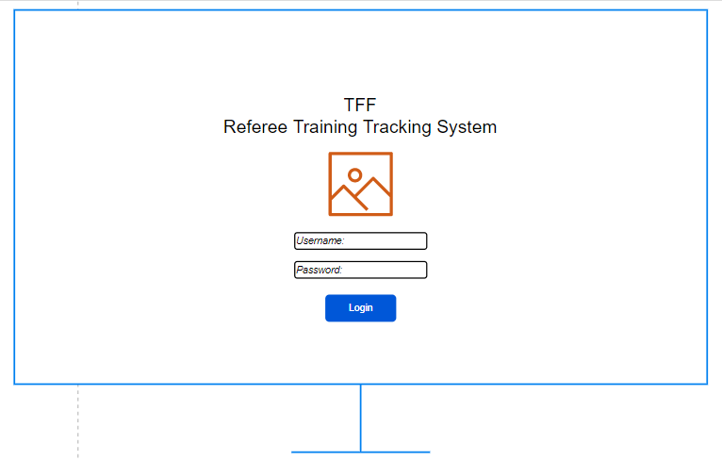
Figure 2:
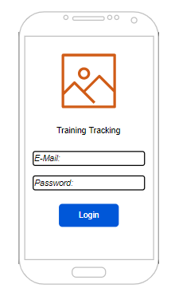

Figure 3:
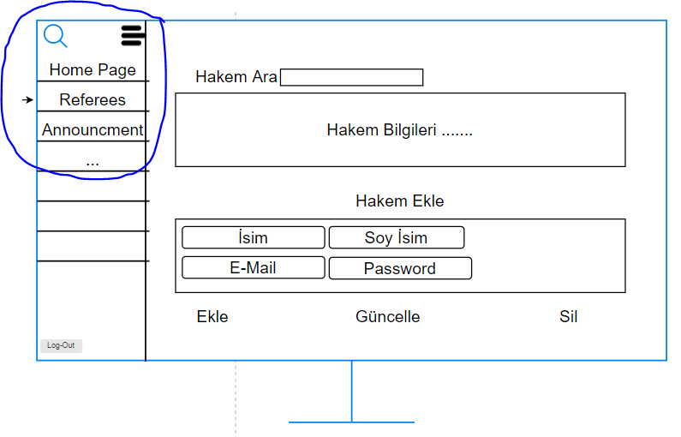
Figure 4:
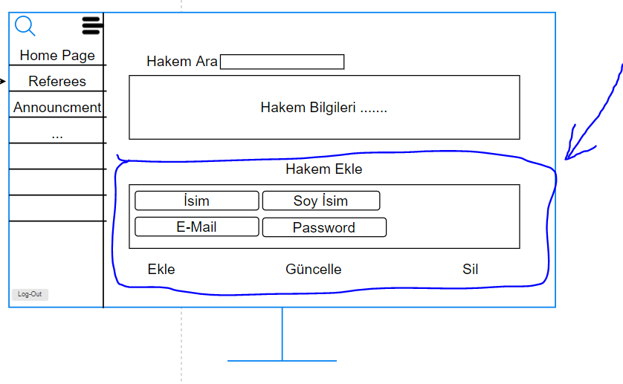

Figure 5:
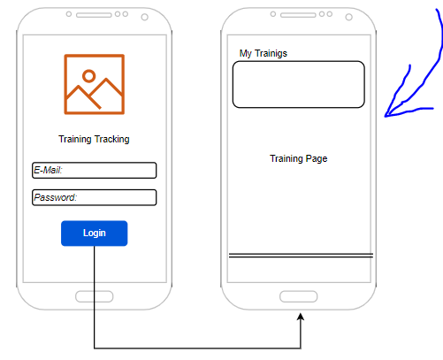

Figure 6:
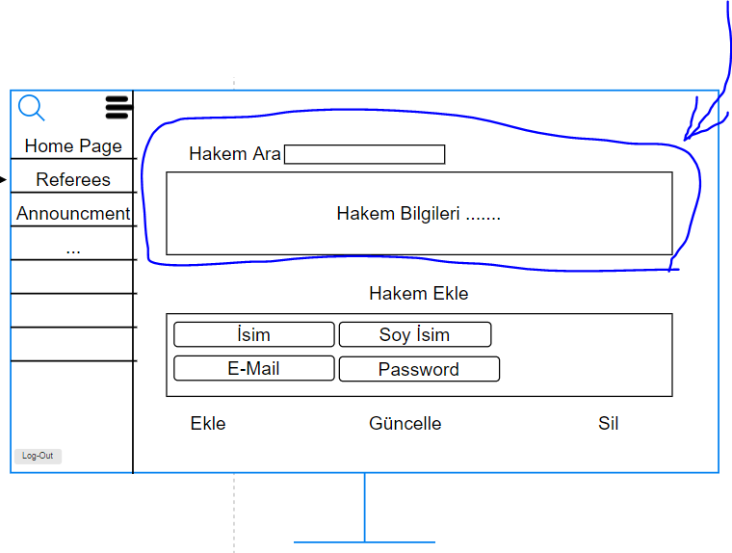

Figure 7:
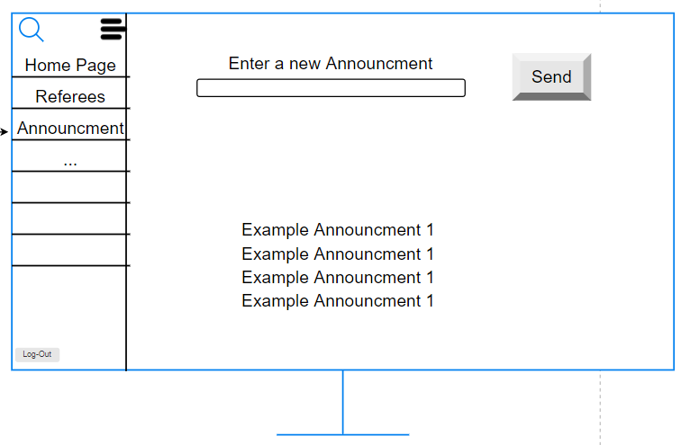
Figure 8:
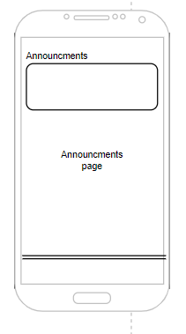

Hardware Interfaces
The use of referees is supported on Android devices. The device from which the application is downloaded must have a minimum of 1 GB of Ram and a dual-core, since it is not an application that requires high processing, the minimum hardware features will be sufficient. In order to access the application, the Play Store must be installed on the device. The application must interact with the Internet (to receive and send data). To download the application, the device must support the Android version of the application.
For TFF use, it is sufficient to access any browser and have internet access.

Software Interfaces
In order for the application to work, Android 6.0 version must be installed on the device. User data is controlled and stored under the MySQL database. In our system, the training information of the user is received and this information is transmitted to TFF top management members. In the announcements section of our application, both referees and TFF senior management members can access the same data and stay in touch.

Communications Interfaces
Protocol Security Setting Port Number(s)
POP3 (receiving mail) Encrypted - SSL 995
POP3 (receiving mail) Unencrypted 110
IMAP (receiving mail) Encrypted – TLS 993
IMAP (receiving mail) Encrypted - SSL 993
HTTP Unencrypted 80
HTTPS Encrypted - SSL 443
MYSQL Unencrypted 3306

System Features

Referee Class 1 <User>

System Feature 1
The training and health information of the user will be followed up.

Description and Priority
With this feature, users can access the training, health, height, weight, age, nutrition etc. Such information will be tracked and used for the user's development.
Priority = High

Stimulus/Response Sequences
Reminders will be sent to the user as a notification to facilitate the follow-up of this feature. If it is not followed, the point of the user will decrease.

Functional Requirements
There should be a simple interface where the user can add this information to the system as input.

System Feature 2
The announcements that users will see will be added to the system.

Description and Priority
Announcements added to the system by TFF can be viewed by users.
Priority = Low

Stimulus/Response Sequences
It is recommended that users follow these announcements to keep up to date with developments.

Functional Requirements
After logging in, the user can access these announcements from the announcements section.

TFF Class 1 <Administrator>

System Feature 1
Adding and deleting users to the system.

Description and Priority
It will allow users to be added and deleted from the system.
Priority = High

Stimulus/Response Sequences
In case users are not processed into the system, users cannot log into the system.

Functional Requirements
After accessing the TFF interface, announcements can enter the system from the announcement page. It can remove existing announcement from the system.

System Feature 2
Adding announcements to the system.

Description and Priority
TFF can add announcements to the system for users to see.
Priority = Low

Stimulus/Response Sequences
If announcements are not added to the system, they cannot notify users of important developments.

Functional Requirements
After accessing the TFF interface, users can enter the system from the Referees page. It can remove existing users from the system.

Nonfunctional System Requirements
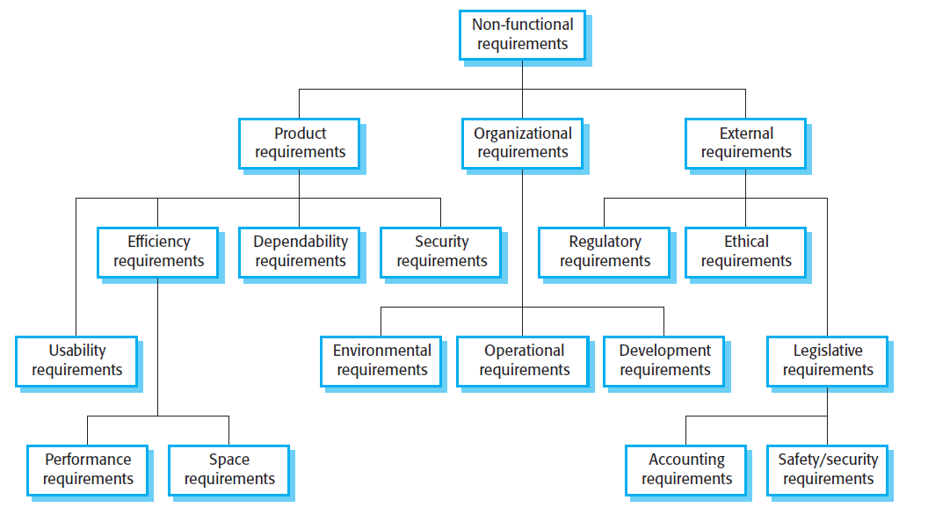

Performance Requirements

ID: NF1
TAG: how long does the entered data go to the database
GIST: sending speed
SCALE: the speed at which the user enters the data
METER: information from 100 entered data during testing
MUST: arrive within 1 minute
WISH: immediately

ID: NF2
TAG: What exercises will be done
GIST: the duration of the workouts to be done
SCALE: How many times will the training be done
METER: which days will be done
MUST: post-workout health information.
WISH: monthly weight information

ID: NF3
TAG: fitness-related athlete information (Proficiency)
GIST: How many seconds did he run 100 meters
SCALE: comparison with other users
METER: How long does a healthy person run 100 meters
MUST: how long is expected to run the distance
WISH: maximum speed ascended

Safety Requirements
It is aimed to register a user from the web portal to log into the application and to prevent unnecessary user registrations and unnecessary spam by sending the information to the user via e-mail or tel.

Security Requirements
User data are stored in secure environments.
Users cannot see each other's data.
Since the user ID will be entered by authorized persons from the webPortal, there will be no user-based problem in authentication processes

Software Quality Attributes
Usability: A simple interface that can be used by all users without age restrictions.
Reliability: User information is stored in secure environments.
Flexibility: Website like mobile or tablet thanks to responsive design
It can be used from different devices.
Testability: The application has been tested against freezing and non-opening conditions.
Sustainability: Our app will be up to date and the developer team will provide it.
Portability: There is no loss of information in case the user changes the device. Because the information is stored on a remote database, not on the device.

Business Rules
Developers will provide the environment for keeping the application up-to-date and protecting personal data.
The administration will follow the referees' training information and provide them access to the application.
Referees will use the App to add training information.

Other Requirements
To use the application, the user must be in an environment connected to the internet.
In accordance with the law on the protection of personal data, the referee information is stored in accordance with the law

System Models

System Context

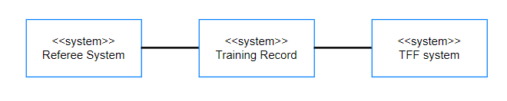

Interaction Models

Use-Case Models

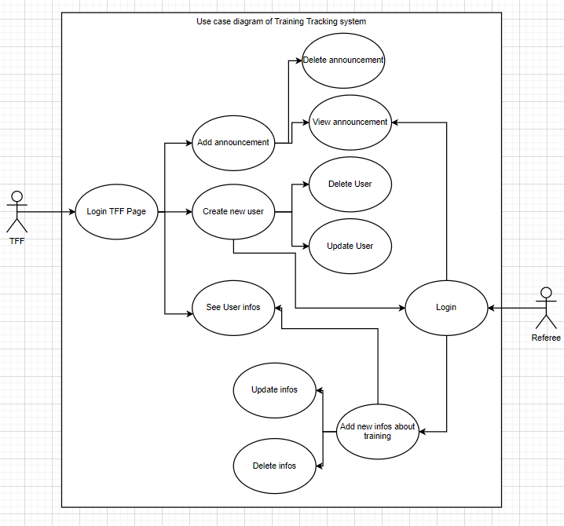

Wireframe

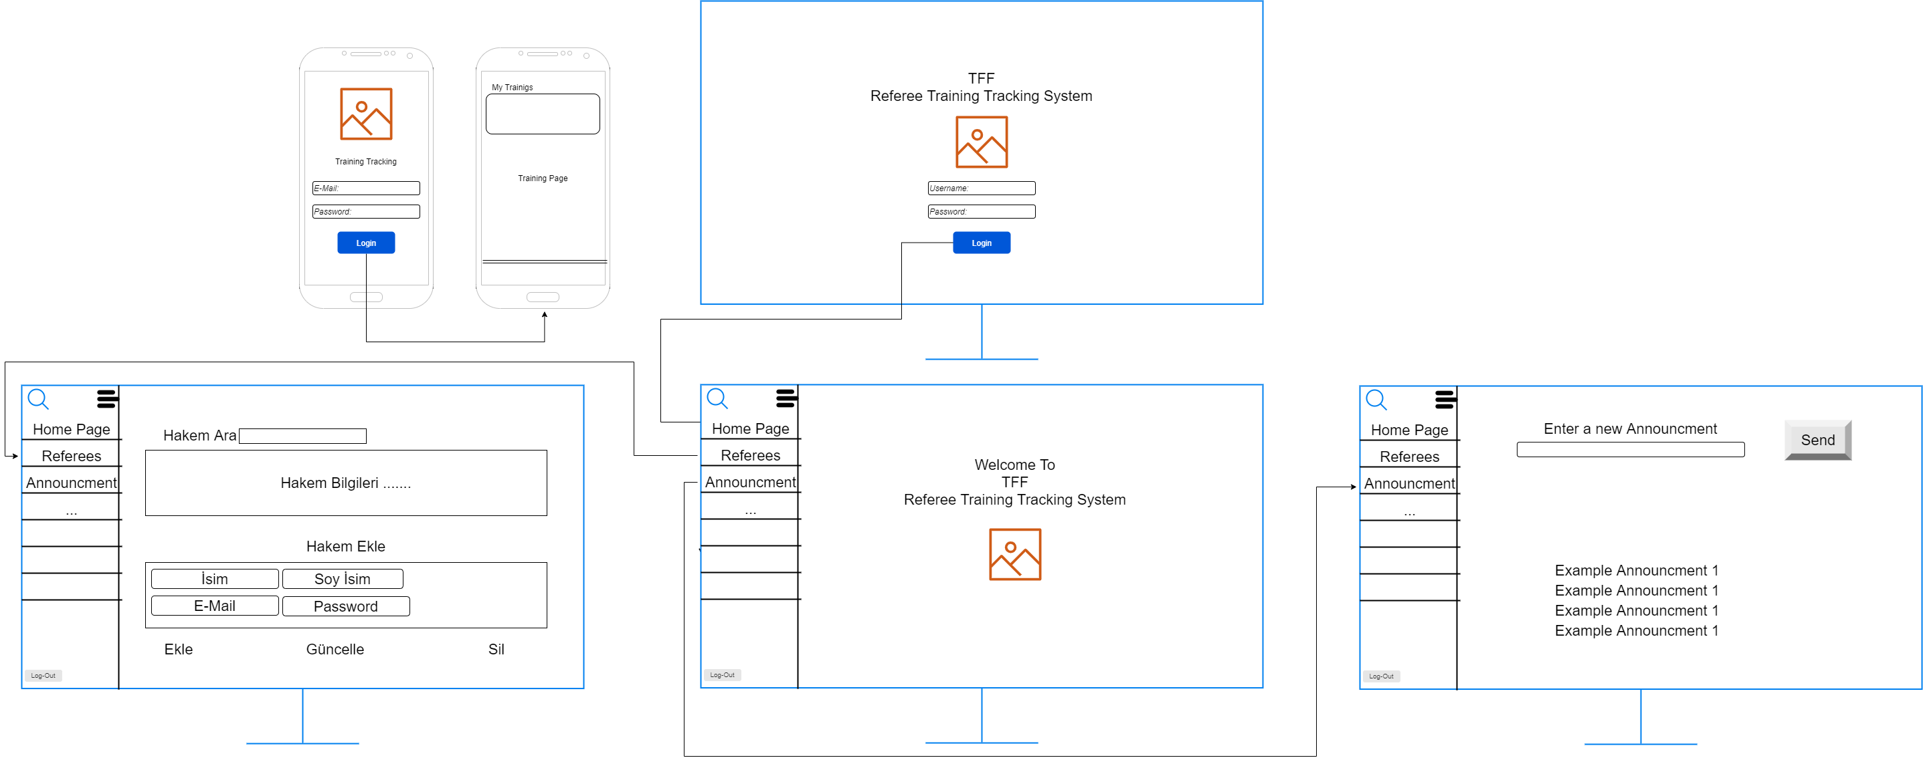

Mental Care system: Transfer data

 | Mental Care system: Transfer data
Actors | Medical receptionist, Patient records system (PRS)
Description | A receptionist may transfer data from the Mentcare system to a general patient record database that is maintained by a health authority. The information transferred may either be updated personal information (address, phone number, etc.) or a summary of the patient’s diagnosis and treatment.
Data | Patient’s personal information, treatment summary
Stimulus | User command issued by medical receptionist
Response | Confirmation that PRS has been updated
Comments | The receptionist must have appropriate security permissions to access the patient information and the PRS.

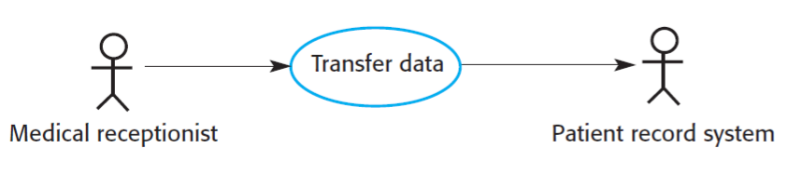

Mental Care system: Register Patient

 | Mental Care system: Register Patient
Actors | Medical receptionist, Patient records system (PRS)
Description | A receptionist may transfer data from the Mentcare system to a general patient record database that is maintained by a health authority. The information transferred may either be updated personal information (address, phone number, etc.) or a summary of the patient’s diagnosis and treatment.
Data | Patient’s personal information, treatment summary
Stimulus | User command issued by medical receptionist
Response | Confirmation that PRS has been updated
Comments | The receptionist must have appropriate security permissions to access the patient information and the PRS.

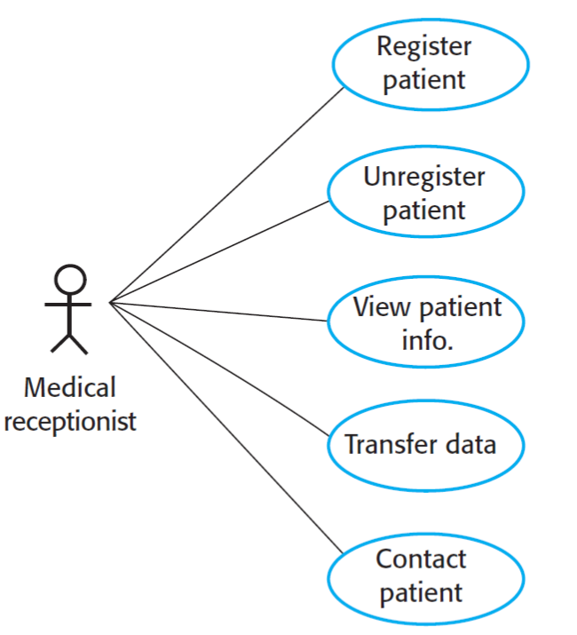

Sequence Diagrams

<Sequence diagrams in the UML are primarily used to model the interactions between the actors and the objects in a system and the interactions between the objects themselves. As the name implies, a sequence diagram shows the sequence of interactions that take place during a particular use case or use case instance. Figure 5.6 is an example of a sequence diagram that illustrates the basics of the notation. This diagram models the interactions involved in the View patient information use case, where a medical receptionist can see some patient information.
The objects and actors involved are listed along the top of the diagram, with a dotted line drawn vertically from these. Annotated arrows indicate interactions between objects. The rectangle on the dotted lines indicates the lifeline of the object concerned (i.e., the time that object instance is involved in the computation). You read the sequence of interactions from top to bottom. The annotations on the arrows indicate the calls to the objects, their parameters, and the return values. This example also shows the notation used to denote alternatives. A box named alt is used with the conditions indicated in square brackets, with alternative interaction options separated by a dotted line.>

View Patient

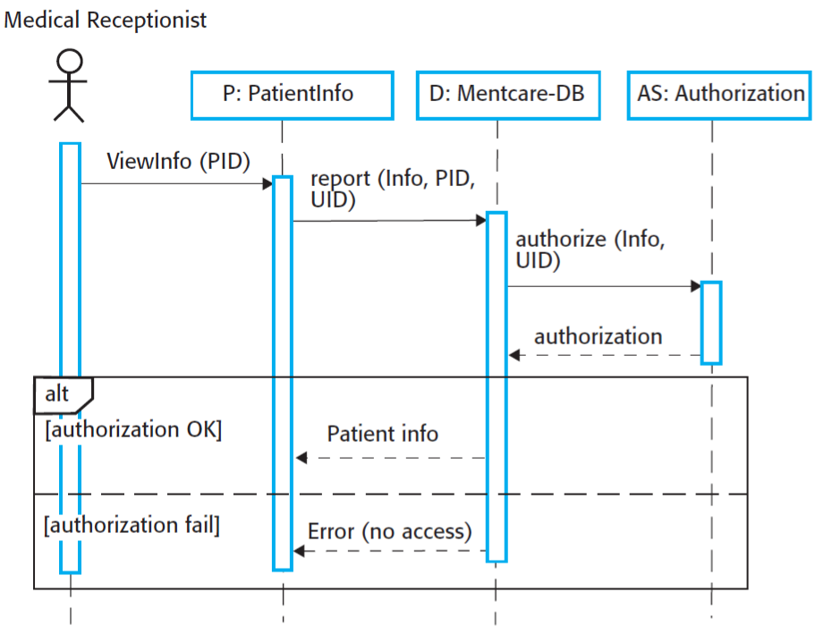
You can read Figure as follows:
1. The medical receptionist triggers the ViewInfo method in an instance P of the
PatientInfo object class, supplying the patient’s identifier, PID to identify the required information. P is a user interface object, which is displayed as a form showing patient information.
2. The instance P calls the database to return the information required, supplying the receptionist’s identifier to allow security checking. (At this stage, it is not important where the receptionist’s UID comes from.)
3. The database checks with an authorization system that the receptionist is authorized for this action.
4. If authorized, the patient information is returned and is displayed on a form on the user’s screen. If authorization fails, then an error message is returned. The box denoted by “alt” in the top-left corner is a choice box indicating that one of the contained interactions will be executed. The condition that selects the choice is shown in square brackets.

Following is a further example of a sequence diagram from the same system that illustrates two additional features. These are the direct communication between the actors in the system and the creation of objects as part of a sequence of operations. In this example, an object of type Summary is created to hold the summary data that is to be uploaded to a national PRS (patient records system). You can read this diagram as follows:
1. The receptionist logs on to the PRS.
2. Two options are available (as shown in the “alt” box). These allow the direct transfer of updated patient information from the Mentcare database to the PRS and the transfer of summary health data from the Mentcare database to the PRS.
3. In each case, the receptionist’s permissions are checked using the authorization system.
4. Personal information may be transferred directly from the user interface object to the PRS. Alternatively, a summary record may be created from the database, and that record is then transferred.
5. On completion of the transfer, the PRS issues a status message and the user logs off.

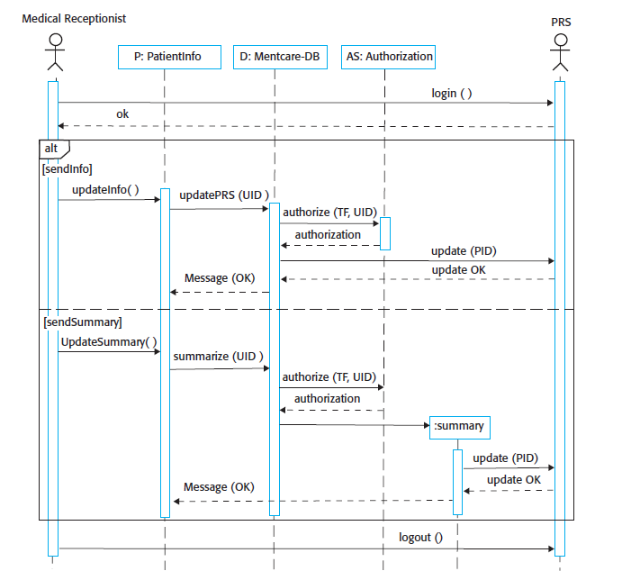

Structural Models

Object and Class Model

<Class diagrams are used when developing an object-oriented system model to show the classes in a system and the associations between these classes. Loosely, an object class can be thought of as a general definition of one kind of system object. An association is a link between classes indicating that some relationship exists between these classes.
When you are developing models during the early stages of the software engineering process, objects represent something in the real world, such as a patient, a prescription, or a doctor. As an implementation is developed, you define implementation objects to represent data that is manipulated by the system. In this section, the focus is on the modeling of real-world objects as part of the requirements or early software design processes. A similar approach is used for data structure modeling.
Class diagrams in the UML can be expressed at different levels of detail. When you are developing a model, the first stage is usually to look at the world, identify the essential objects, and represent these as classes. The simplest way of writing these diagrams is to write the class name in a box. You can also note the existence of an association by drawing a line between classes. For example, next figure shows that objects of class Patient are also involved in relationships with a number of other classes
Figure shows an important feature of class diagrams—the ability to show how many objects are involved in the association 1..1, means that there is a 1:1 relationship between objects of these classes. That is, each patient has exactly one record, and each record maintains information about exactly one patient.
As you can see from Figure, other multiplicities are possible. You can define that an exact number of objects are involved (e.g., 1..4) or, by using a *, indicate that there are an indefinite number of objects involved in the association. For example, the (1..*) multiplicity in Figure on the relationship between Patient and Condition shows that a patient may suffer from several conditions and that the same condition may be associated with several patients.>

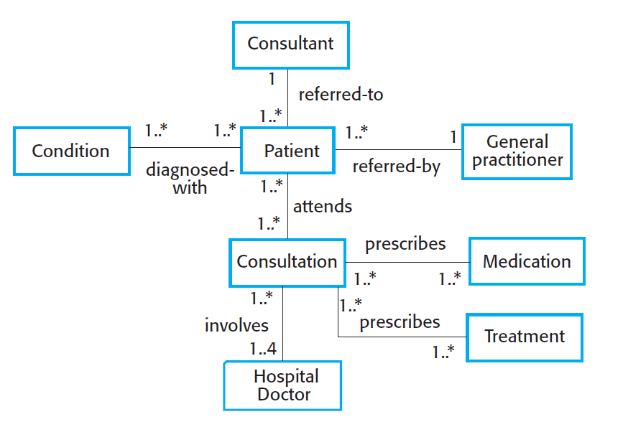

Consultation Class (For important classes only)

<provide details about important classes>

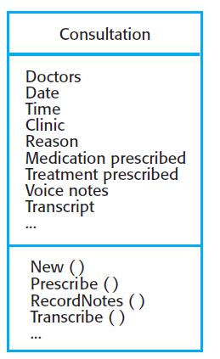

Consultation class keeps the details of each consultation and interacts with

Doctor Class

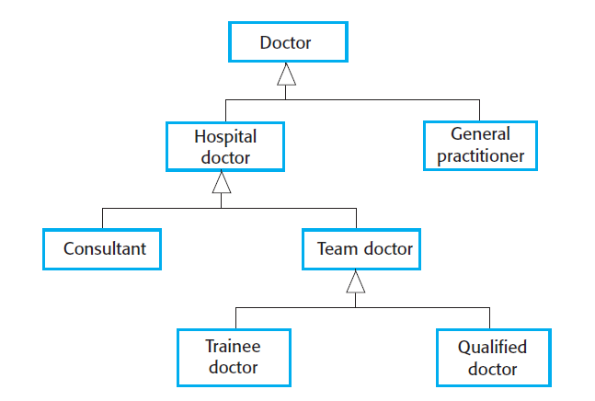

GameEngine Class

“GameEngine” is the façade class of the entire system; therefore it handles almost everything about game logic via using its methods. Moreover, “GameEngine” class starts the main game loop and inside the loop, “GameEngine” class repositions the Balls, Bullets and the Stick according to their speed with its updateObjects() method; then it checks the collision between balls, bricks and the stick and changes their states accordingly. Finally, at the end of the loop cycle it draws the objects to the screen using “GameVisualizer” class, checks the game end conditions using isGameOver() method. If the isGameOver() methods return is true. It terminates the game loop and passes the flow of control back to the MainMenu class.

Behavioral Models

<Behavioral models are models of the dynamic behavior of a system as it is executing. They show what happens or what is supposed to happen when a system responds to a stimulus from its environment. These stimuli may be either data or events:
1. Data becomes available that has to be processed by the system. The availability of the data triggers the processing.
2. An event happens that triggers system processing. Events may have associated data, although this is not always the case.
Many business systems are data-processing systems that are primarily driven by data. They are controlled by the data input to the system, with relatively little external event processing. Their processing involves a sequence of actions on that data and the generation of an output. For example, a phone billing system will accept information about calls made by a customer, calculate the costs of these calls, and generate a bill for that customer.
By contrast, real-time systems are usually event-driven, with limited data processing. For example, a landline phone switching system responds to events such as “handset activated” by generating a dial tone, pressing keys on a handset by capturing the phone number, and so on.>

Data Driven (Activity Diagrams / Sequence Diagrams)

<Data-driven models show the sequence of actions involved in processing input data and generating an associated output. They can be used during the analysis of requirements as they show end-to-end processing in a system. That is, they show the entire sequence of actions that takes place from an initial input being processed to the corresponding output, which is the system’s response.
Data-flow models are useful because tracking and documenting how data associated with a particular process moves through the system help analysts and designers understand what is going on in the process. DFDs are simple and intuitive and so are more accessible to stakeholders than some other types of model. It is usually possible to explain them to potential system users who can then participate in validating the model>

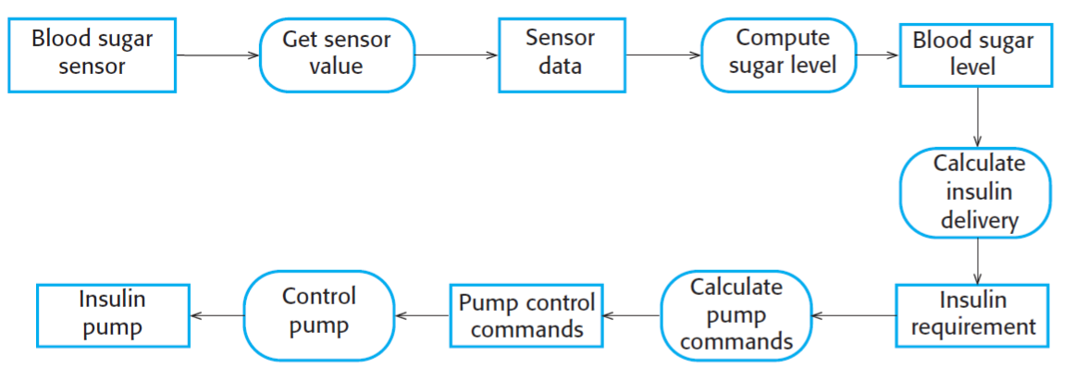Activity Model of insulin pump

Data Driven (Sequence Diagrams)

<An alternative way of showing the sequence of processing in a system is to use UML sequence diagrams. You have seen how these diagrams can be used to model interaction, but if you draw these so that messages are only sent from left to right, then they show the sequential data processing in the system. Figure 5.15 illustrates this, using a sequence model of processing an order and sending it to a supplier.
Sequence models highlight objects in a system, whereas data-flow diagrams highlight the operations or activities. In practice, nonexperts seem to find data-flow diagrams more intuitive, but engineers prefer sequence diagrams.>

Sequence diagram for order purchase

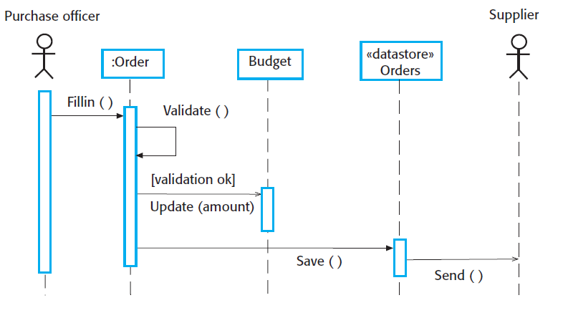

Sequence diagram for order purchase

Event Driven Models (State Diagrams)

<Event-driven modeling shows how a system responds to external and internal events. It is based on the assumption that a system has a finite number of states and that events (stimuli) may cause a transition from one state to another. For example, a system controlling a valve may move from a state “Valve open” to state “Valve closed” when an operator command (the stimulus) is received. This view of a system is particularly appropriate for real-time systems. Event-driven modeling is used extensively when designing and documenting real-time systems.
In UML state diagrams, rounded rectangles represent system states. They may include a brief description (following “do”) of the actions taken in that state. The labeled arrows represent stimuli that force a transition from one state to another. You can indicate start and end states using filled circles, as in activity diagrams.
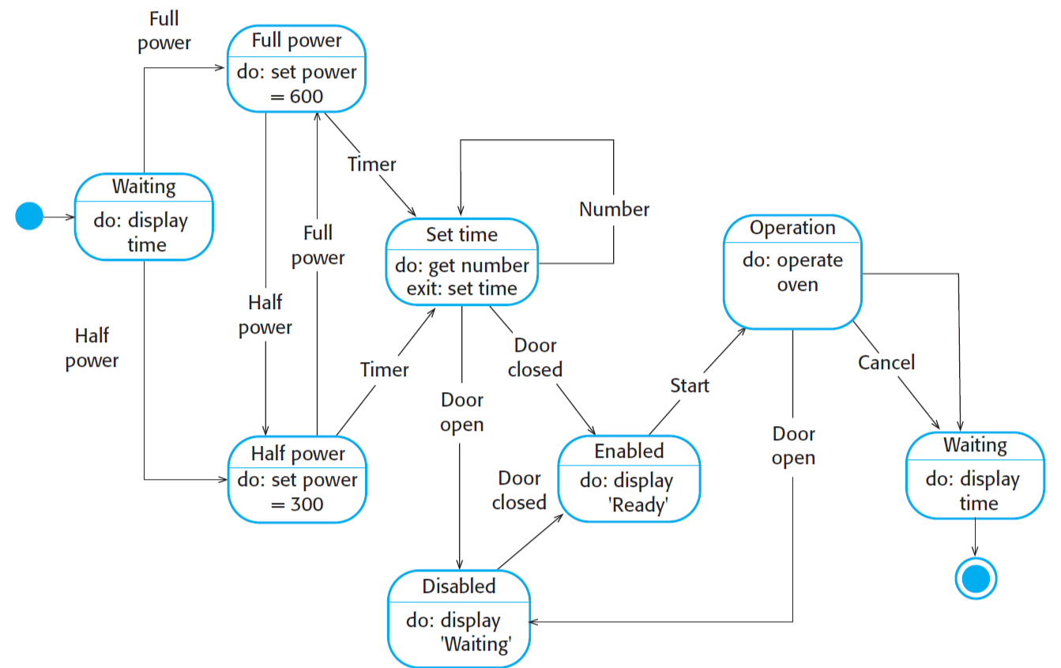

User Interface

Test

References
For the references you can use programs like Zotero (https://www.zotero.org/)

Object-Oriented Software Engineering, Using UML, Patterns, and Java, 2nd Edition, by Bernd Bruegge and Allen H. Dutoit, Prentice-Hall, 2004, ISBN: 0-13-047110-0.

Appendix A: Glossary
<Define all the terms necessary to properly interpret the SRS, including acronyms and abbreviations. You may wish to build a separate glossary that spans multiple projects or the entire organization, and just include terms specific to a single project in each SRS.>

